**Creating Microservices for account and loan**

**For account microservice:**

* **Step 1: open the spring initializer.**
* **Do the following steps.**
* **And then generate it.**
* **And after extracting the folder put it a folder named microservices.**

* **Step 2: Open the IntelliJ idea, and open the accounts folder in it.**

**It will look like this shown below in the screenshot:**

* **Step 3: Now create a new package inside com.cognizant.account and name it Controller**

* **And then in the Controller package make a class named AccountController.**
* **Code for AccountContoller is given below:**
* AccountController.java

package com.cognizant.account.controller;  
  
import org.springframework.web.bind.annotation.*;  
  
import java.util.Map;  
  
@RestController  
@RequestMapping("/accounts")  
public class AccountController {  
  
 @GetMapping("/{number}")  
 public Map<String, Object> getAccountDetails(@PathVariable String number) {  
 return Map.*of*(  
 "number", number,  
 "type", "savings",  
 "balance", 234343  
 );  
 }  
}

* **Step 4: Now create a new class named Account in com.cognizant.account.**
* **Code for account class is given below:**
* Account.java

package com.cognizant.account;  
  
public class Account {  
 private String number;  
 private String type;  
 private double balance;  
  
 // Constructor  
 public Account(String number, String type, double balance) {  
 this.number = number;  
 this.type = type;  
 this.balance = balance;  
 }  
  
 // Getters  
 public String getNumber() {  
 return number;  
 }  
  
 public String getType() {  
 return type;  
 }  
  
 public double getBalance() {  
 return balance;  
 }  
}

* Code for AccountApplication.java

package com.cognizant.account;  
  
import org.springframework.boot.SpringApplication;  
import org.springframework.boot.autoconfigure.SpringBootApplication;  
  
@SpringBootApplication  
public class AccountApplication {  
  
 public static void main(String[] args) {  
 SpringApplication.*run*(AccountApplication.class, args);  
 }  
  
}

* pom.xml

<project xmlns="http://maven.apache.org/POM/4.0.0"  
 xmlns:xsi="http://www.w3.org/2001/XMLSchema-instance"  
 xsi:schemaLocation="http://maven.apache.org/POM/4.0.0 https://maven.apache.org/xsd/maven-4.0.0.xsd">  
 <modelVersion>4.0.0</modelVersion>  
  
 <parent>  
 <groupId>org.springframework.boot</groupId>  
 <artifactId>spring-boot-starter-parent</artifactId>  
 <version>3.1.5</version> <!-- This version is safe and available -->  
 <relativePath/> <!-- lookup parent from repository -->  
 </parent>  
  
 <groupId>com.cognizant</groupId>  
 <artifactId>account</artifactId>  
 <version>0.0.1-SNAPSHOT</version>  
 <name>account</name>  
 <description>Account Microservice</description>  
  
 <properties>  
 <java.version>17</java.version>  
 </properties>  
  
 <dependencies>  
 <dependency>  
 <groupId>org.springframework.boot</groupId>  
 <artifactId>spring-boot-starter-web</artifactId>  
 </dependency>  
  
 <dependency>  
 <groupId>org.springframework.boot</groupId>  
 <artifactId>spring-boot-starter-test</artifactId>  
 <scope>test</scope>  
 </dependency>  
 </dependencies>  
  
 <build>  
 <plugins>  
 <plugin>  
 <groupId>org.springframework.boot</groupId>  
 <artifactId>spring-boot-maven-plugin</artifactId>  
 </plugin>  
 </plugins>  
 </build>  
  
</project>

<project xmlns="http://maven.apache.org/POM/4.0.0"  
 xmlns:xsi="http://www.w3.org/2001/XMLSchema-instance"  
 xsi:schemaLocation="http://maven.apache.org/POM/4.0.0 https://maven.apache.org/xsd/maven-4.0.0.xsd">  
 <modelVersion>4.0.0</modelVersion>  
  
 <parent>  
 <groupId>org.springframework.boot</groupId>  
 <artifactId>spring-boot-starter-parent</artifactId>  
 <version>3.1.5</version> <!-- This version is safe and available -->  
 <relativePath/> <!-- lookup parent from repository -->  
 </parent>  
  
 <groupId>com.cognizant</groupId>  
 <artifactId>account</artifactId>  
 <version>0.0.1-SNAPSHOT</version>  
 <name>account</name>  
 <description>Account Microservice</description>  
  
 <properties>  
 <java.version>17</java.version>  
 </properties>  
  
 <dependencies>  
 <dependency>  
 <groupId>org.springframework.boot</groupId>  
 <artifactId>spring-boot-starter-web</artifactId>  
 </dependency>  
  
 <dependency>  
 <groupId>org.springframework.boot</groupId>  
 <artifactId>spring-boot-starter-test</artifactId>  
 <scope>test</scope>  
 </dependency>  
 </dependencies>  
  
 <build>  
 <plugins>  
 <plugin>  
 <groupId>org.springframework.boot</groupId>  
 <artifactId>spring-boot-maven-plugin</artifactId>  
 </plugin>  
 </plugins>  
 </build>  
  
</project>

* **Make sure that in the application.properties .. the server is set to 8081**
* **Step 5: Now run the main AccountApplication:**

**OUTPUT in the postman:**

**For loan microservice :**

* **Step 1: Now for loan microservice open the spring initializr and do the following.**

* **Now generate this folder, extract it , and then open it in the microservices folder created earlier.**
* **After all this open IntelliJ and then open loan folder.**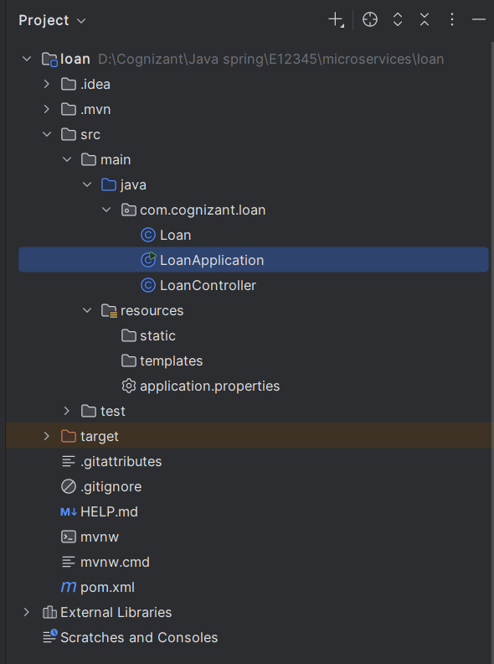
* **Step 2: Now in the com.cognizant.loan package,**
* **Create a new class named Loan.**
* **Code for Loan is given below:**
* Loan.java

package com.cognizant.loan;  
  
public class Loan {  
 private String number;  
 private String type;  
 private int loan;  
 private int emi;  
 private int tenure;  
  
 public Loan(String number, String type, int loan, int emi, int tenure) {  
 this.number = number;  
 this.type = type;  
 this.loan = loan;  
 this.emi = emi;  
 this.tenure = tenure;  
 }  
  
 public String getNumber() {  
 return number;  
 }  
  
 public String getType() {  
 return type;  
 }  
  
 public int getLoan() {  
 return loan;  
 }  
  
 public int getEmi() {  
 return emi;  
 }  
  
 public int getTenure() {  
 return tenure;  
 }  
}

* **Step 3: Now again create anew class named LoanControlle rin the same package**
* **Code for LoanController:**
* LoanController.java

package com.cognizant.loan;  
  
import org.springframework.web.bind.annotation.*;  
  
@RestController  
@RequestMapping("/loans")  
public class LoanController {  
  
 @GetMapping("/{number}")  
 public Loan getLoanDetails(@PathVariable String number) {  
 return new Loan(number, "car", 400000, 3258, 18);  
 }  
}

* **Code for pom.xml:**

<?xml version="1.0" encoding="UTF-8"?>  
<project xmlns="http://maven.apache.org/POM/4.0.0"  
 xmlns:xsi="http://www.w3.org/2001/XMLSchema-instance"  
 xsi:schemaLocation="http://maven.apache.org/POM/4.0.0 https://maven.apache.org/xsd/maven-4.0.0.xsd">  
  
 <modelVersion>4.0.0</modelVersion>  
  
 <parent>  
 <groupId>org.springframework.boot</groupId>  
 <artifactId>spring-boot-starter-parent</artifactId>  
 <version>3.1.5</version>  
 <relativePath/>  
 </parent>  
  
 <groupId>com.cognizant</groupId>  
 <artifactId>loan</artifactId>  
 <version>0.0.1-SNAPSHOT</version>  
 <name>loan</name>  
 <description>Demo project for Spring Boot</description>  
  
 <properties>  
 <java.version>17</java.version>  
 </properties>  
  
 <dependencies>  
  
 <dependency>  
 <groupId>org.springframework.boot</groupId>  
 <artifactId>spring-boot-starter-web</artifactId>  
 </dependency>  
  
  
 <dependency>  
 <groupId>org.springframework.boot</groupId>  
 <artifactId>spring-boot-devtools</artifactId>  
 <scope>runtime</scope>  
 <optional>true</optional>  
 </dependency>  
  
  
 <dependency>  
 <groupId>org.springframework.boot</groupId>  
 <artifactId>spring-boot-starter-test</artifactId>  
 <scope>test</scope>  
 </dependency>  
 </dependencies>  
  
 <build>  
 <plugins>  
  
 <plugin>  
 <groupId>org.apache.maven.plugins</groupId>  
 <artifactId>maven-compiler-plugin</artifactId>  
 <version>3.11.0</version>  
 <configuration>  
 <source>17</source>  
 <target>17</target>  
 </configuration>  
 </plugin>  
  
  
 <plugin>  
 <groupId>org.springframework.boot</groupId>  
 <artifactId>spring-boot-maven-plugin</artifactId>  
 </plugin>  
 </plugins>  
 </build>  
  
</project>

* **Code for LoanApplication:**
* LoanApplication.java

package com.cognizant.loan;  
  
import org.springframework.boot.SpringApplication;  
import org.springframework.boot.autoconfigure.SpringBootApplication;  
  
@SpringBootApplication  
public class LoanApplication {  
 public static void main(String[] args) {  
 SpringApplication.*run*(LoanApplication.class, args);  
 }  
}

* **Make sure the port in application.properties for loan is 8082.**

**Step 4: Run Loan.Application**

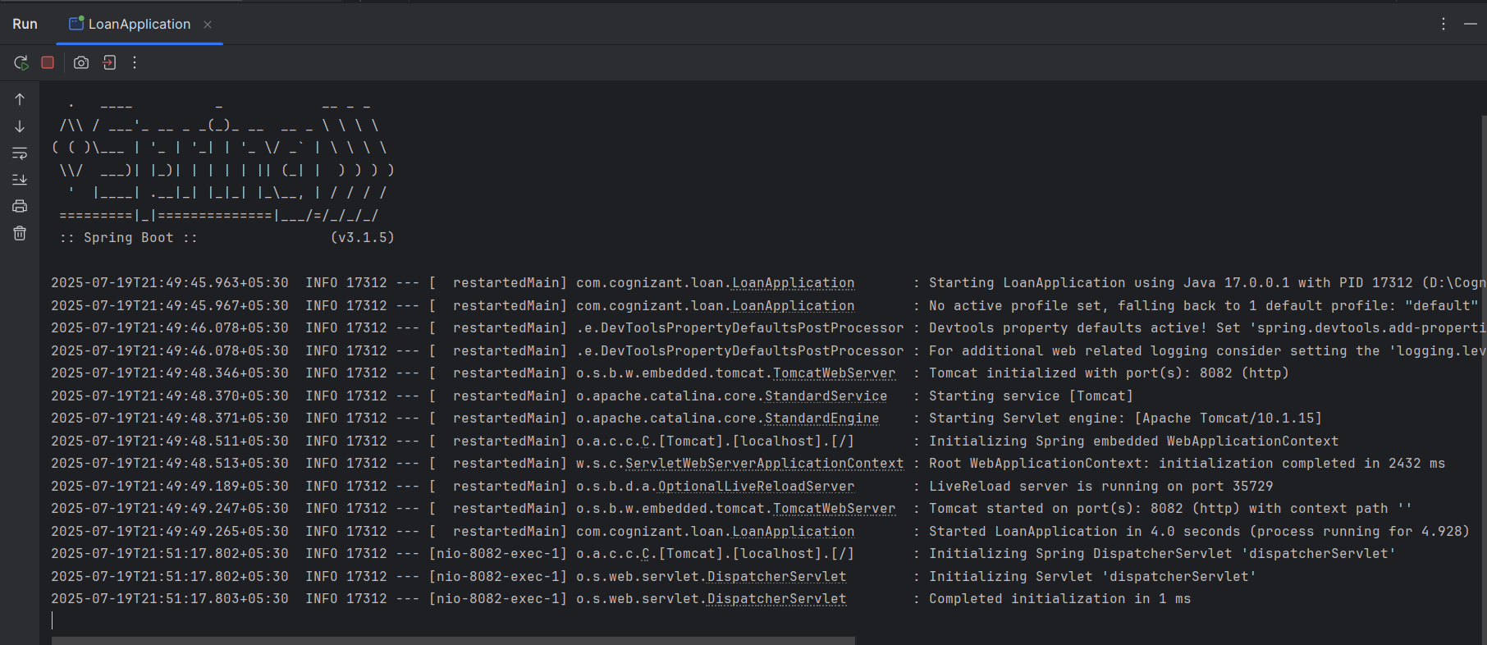

**OUTPUT in the postman:**

